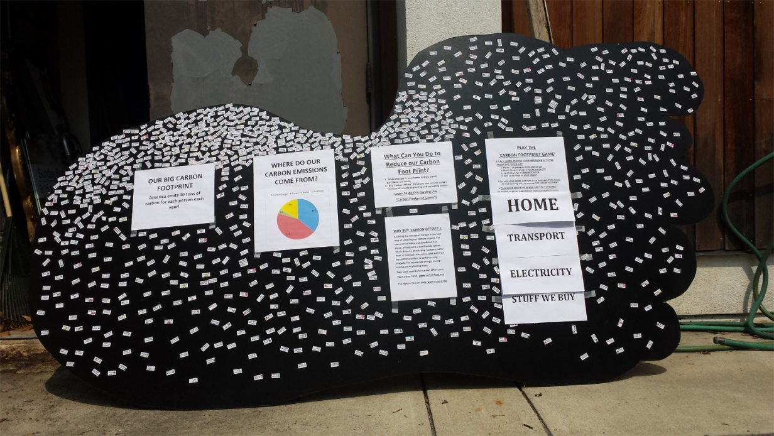
Big Foot is coming!
Dear Coordinating Team,
We at the UUCF Climate Action Group are writing to update you on the Big Foot Game for carbon reduction planned for this winter and spring. I hope this information can help you determine whether or how this project could fit into services, announcements, and e-newsletters related to our four topics. These topics are:
- January: Home and Energy
- February: Food
- March: Transportation
- April: Reduce, Reuse, Recycle
We have a lead person and team for each of the topics and we’re happy to provide more information on the specific themes.
Starting in late December, we will place the 5’ Big Carbon Footprint in the commons after services, and bring it out each Sunday starting January 9. We hope to motivate the children in RE and UUCF members to ask questions about reducing their personal and family carbon footprints, just as UUCF has been doing through the Paris Pledge and the new light fixtures being installed. For each topic area, children and members will receive stickers for their already completed carbon footprint reductions (affirmations) and for stretching to pledge new steps. They will place the stickers on the large footprint to make it disappear. We will finish with strong support for the UUCF Yard Sale and a celebration May 7.
If you want to discuss this further, please call me at 703-759-0218 or email me at facsericg@gmail.com.
I look forward to playing this game together.
Eric Goplerud
Big Foot is coming!
How to Shrink the Big, Dark, Carbon Footprint by Earning Stickers for Being a Carbon Footprint Super-Hero
Make the carbon on the Big Foot disappear under our stickers!
More and more people today know that climate change is real, is caused by people, and is hurting people and the web of life right now. We know that our actions as individuals, families, congregations, businesses – and yes, even governments – can make a difference. Now we at UUCF, with joyful spirits, will share ways to be a part of this important work together.
Bring your hearts and laughter to this game of sharing and learning.
What steps have you already taken to reduce your carbon footprint? And what else can you do today, this week, to reduce it just a little more? After services and in RE classes, we will receive stickers to record our efforts and we'll challenge each other with ideas for ways to obtain more stickers by pledging new actions each week.
We will use our stickers to cover as much black (carbon) as possible on the Big Foot, reducing the visible black as a symbol of how we at UUCF are reducing our carbon footprints. Our UUCF campus is taking steps to reduce its carbon footprint by changing all lights to LEDs. What can you do?
The game will cover four topics. Every Sunday, we will offer handouts, ideas, and inspiration so you can pick action steps that appeal to you. The UUCF Climate Action Group members have been studying the topics subjects so we can advise you and answer your questions.
HOME and ENERGY USE (January)
FOOD and WATER (February)
TRANSPORTATION (March)
REDUCE, REUSE, RECYCLE (April)
On the first Sunday in May, we will have a celebration for all the children and adults who participate, and share what we’ve done to make this a better environment.
The UUCF Climate Action Group is looking forward to playing this game with you!
If you have any questions, please contact Eric Goplerud at 703-759-0218 or facsericg@gmail.com.
Big Foot is coming
How to Huff & Puff & Shrink the Big, Black, Scary Carbon Footprint While Earning Stickers for Being a CFP (Carbon Footprint) Super-Hero:
Make the carbon on Big Foot disappear under our stickers. Bring your hearts and laughter to this game of sharing and learning.
For parents: More and more people today know that climate change is real, is caused by people, and is hurting people and the web of life right now. We know that our actions as individuals, families, congregations, businesses – and yes, even governments – can make a difference. Now we at UUCF, with joyful spirits, will share ways to be a part of this important work together.
The UUCF Climate Action Group members invite you and your whole families to play this sticker game. We especially like to have your children ask questions of the adults, asking what each of us is doing to make this a safer, healthier place for them to grow up in. We hope that a lot of the discussion will focus on steps we are already taking to reduce our carbon footprint (the children and you get stickers for that) and we ask each of us pledge a new action, small or big. Your children will get stickers to put on Big Carbon Footprints in each RE classroom, and you will get stickers to place on the Big Foot in the Commons.
We will be talking with teachers and the RE classes in the chapel. Sharing together steps we are already taking to cut our carbon footprints – and pledging new actions – will take little time and not interfere with the RE curriculum.
The game will cover four subjects. Every Sunday, we will offer hand-outs, ideas and inspiration so you can pick to your heart's content which action step appeals to you. The UUCF Climate Action Group members have been studying the subjects of HOME AND ENERGY USE (January), FOOD and WATER (February), TRANSPORTATION (March), and the THREE R'S (REDUCE< REUSE< RECYCLE: April) so we can advise you and answer your questions.
Our goal is to cover as much black (carbon) on Big Foot with stickers as possible, reducing this visible black as a symbol of how we at UUCF are reducing our carbon footprints. On the first Sunday in May, we will have a celebration for all the children and adults who participate, and share what we’ve done to make this a better environment.
The UUCF Climate Action Group is looking forward to playing this game together with you. Please contact Eric Goplerud 7030759-0218 facsericg@gmail.com.

