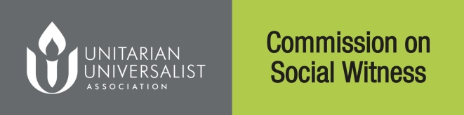
Comment Worksheet for draft
Statement Of Conscience:

“Escalating Inequality”

This form for planning purposes only - comments must be submitted at www.uua.org/socialwitness by February 1, 2017 at 5:00 P.M. Pacific.

Submitting Congregation Information |  |  | Individual Completing Form
Name Of Congregation  Address  City State/Province  Postal/Zip Code  (Note: Only One Collected Submission Per Congregation Permitted) |  |  | Name Of Submitter  Address  City State/Province  Postal/Zip Code  Email  Position Or Role (If Any):
Source Of Comments Below (Mark Best Choice): |  |  | Rate Overall Impressions (Circle Number Matching Best Judgment)
Denominational Affairs Committee  RE Program  Social Action/Justice Committee  Post-Sermon Discussion Or Open Meeting  Circle Study Group  Other  Estimated Number Of Individuals Involved: |  |  | How Aware Is Your Group Of The CSAI Process? | Not At All - A Lot  0 1 2 3 4
 |  |  | General Impression Of Draft Statement Of Conscience (SOC)? | Strongly Disliked - Strongly Liked  0 1 2 3 4
 |  |  | Is This SOC A Springboard To Action? | Not At All – Definitely  0 1 2 3 4
 |  |  | Does This SOC Help To Define UUism? | Not At All – Definitely  0 1 2 3 4
What are the strengths of this statement?

What are the weaknesses/omissions?

What specific changes in wording do you suggest? Start each suggestion with the specific line number where you propose the change.
Deadline: |  | February 1, 2017, By 5:00 P.M. Pacific Time

