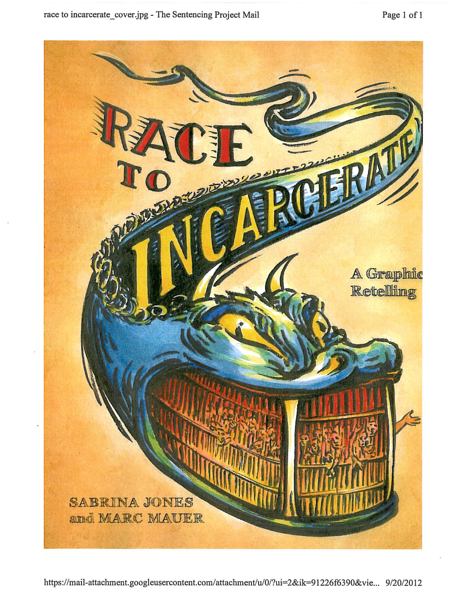 | Science, Reason & Religion  invites you to join us for a timely presentation and a discussion of crime and punishment in America  ◄●►  America's Race to Incarcerate:  Causes, Consequences, and Prospects for Reform  Speaker: Marc Mauer  Executive Director, The Sentencing Project  ◄●►  Sunday, October 25, 2015, 12:30 PM  in the Sanctuary (main building) at the  Unitarian Congregation of Fairfax  2709 Hunter Mill Road, Oakton  Contact: anekimken@cox.net

